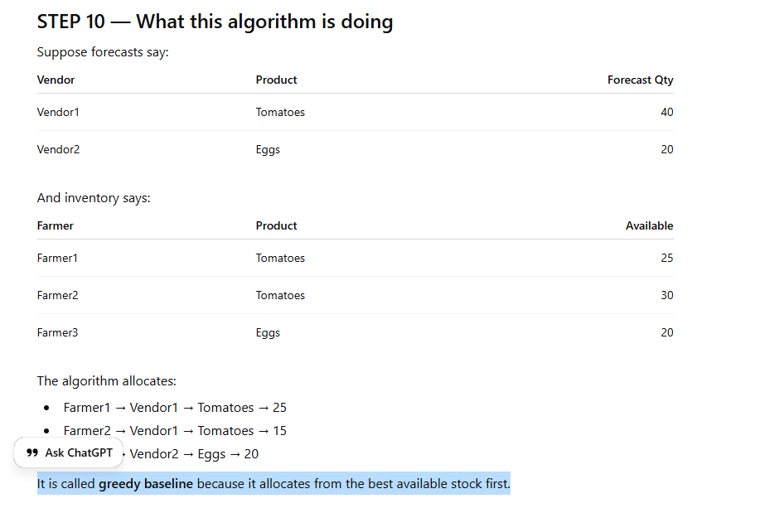
What this algorithm is doing
Suppose forecasts say:
Vendor | Product | Forecast Qty
Vendor1 | Tomatoes | 40
Vendor2 | Eggs | 20
And inventory says:
Farmer | Product | Available
Farmer1 | Tomatoes | 25
Farmer2 | Tomatoes | 30
Farmer3 | Eggs | 20
The algorithm allocates:
- Farmer1 → Vendor1 → Tomatoes → 25
- Farmer2 → Vendor1 → Tomatoes → 15
- Farmer3 → Vendor2 → Eggs → 20
It is called greedy baseline because it allocates from the best available stock first.

